Subdivision Application

(Instructions)

**WHAT TO DO**:

Submit this completed checklist and all supporting documents to City staff and pay the application fee outlined in the City’s Fee Schedule. Before applying, you may schedule a pre-application meeting with the Planning Commission to review a concept plan and/or other elements of your application.

**WHAT TO EXPECT:**

The Planning Commission and City staff will review your application and determine whether it is complete. If your application is complete, or if the Planning Commission decides to waive the incomplete requirements, the Planning Commission and City staff will review and respond to your application within **30 business days**. You may be required to revise your application to conform to City development standards or to better protect the health and safety of Woodland Hills residents.

The subdivision application process is governed by the Subdivision Chapter of the City’s ordinances. The flowchart below summarizes the review and approval process for subdivision applications.

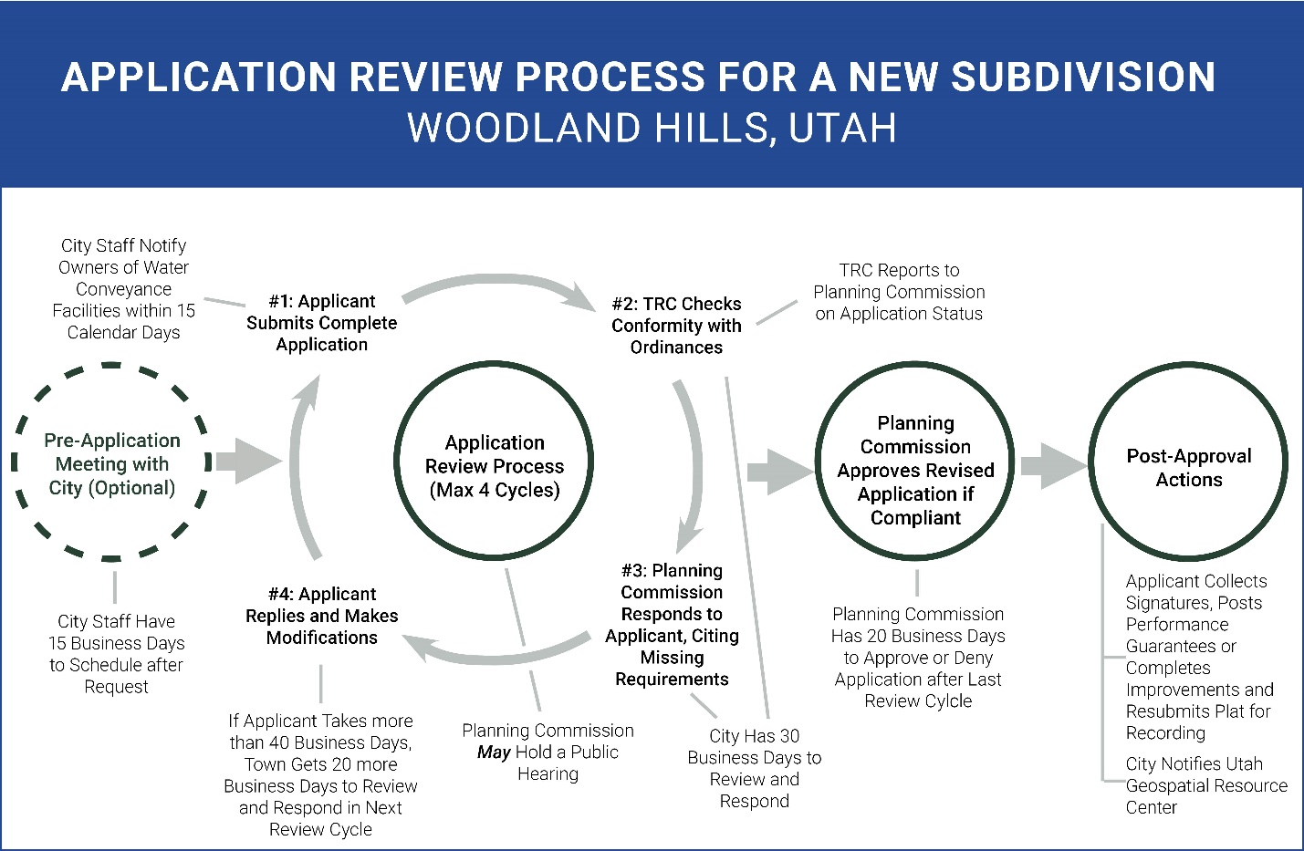

Subdivision Application

Name of Proposed Subdivision: _________________________________________________

*THIS BOX IS FOR OFFICIAL USE ONLY:*

Date Received: __________________

Receipt #: ______________________

Amount Paid: ___________________

_________________________________________________________________________________

County Tax Parcel Number: _____________________________________________________

Current Zoning of Property: _____________________________________________________

- - - - - - - - - - - - - - - - - - - - - - - - - - - - CONTACT INFORMATION - - - - - - - - - - - - - - - - - - - - - - - - - - - -

|  |  |
| --- | --- |
| Applicant Information  Name: _______________________________________________  Phone: _______________________________________________  Email: _______________________________________________ | Property Owner #1 Information  Name: _______________________________________________  Phone: _______________________________________________  Email: _______________________________________________ |
| Property Owner #2 Information (If Applicable)  Name: _______________________________________________  Phone: _______________________________________________  Email: _______________________________________________ | Property Owner #3 Information (If Applicable)  Name: _______________________________________________  Phone: _______________________________________________  Email: _______________________________________________ |
| Engineer’s Information  Name: _______________________________________________  Phone: _______________________________________________  Email: _______________________________________________ | Surveyor’s Information  Name: _______________________________________________  Phone: _______________________________________________  Email: _______________________________________________ |

If the property to be subdivided has more than three owners, attach supplemental information for remaining owners.

- - - - - - - - - - - - - - - - - - - - - - - - - SUBDIVISION APPLICATION DOCUMENT CHECKLIST - - - - - - - - - - - - - - - - - - - - - - - - -

1. **An approved land use application** that describes how the property will be used after it is subdivided or developed.
   1. If the intended use is permitted by right under City ordinances, the land use application must include citations to the specific ordinance(s) that the applicant believes authorizes the intended use.
   2. If the intended use requires a conditional use permit or is otherwise conditioned on City approval, the land use application must include an approved, City-issued permit authorizing the intended use. Should an applicant seek a use permit concurrently with a related subdivision application, the subdivision application shall be considered incomplete until the use permit is issued.
   3. If the intended use is prohibited under City ordinances and requires a variance or rezone, the land use application must include an approved, City-issued variance or rezone authorizing the intended use. Should an applicant seek a variance or rezone concurrently with a related subdivision application, the subdivision application shall be considered incomplete until the variance or rezone is issued.
   4. If the intended use is a Planned Unit Development (PUD), the land use application must include a City-issued approval authorizing the intended use.
2. **A plat**, which must be prepared and certified by a Professional Land Surveyor licensed by the State of Utah. Drawings shall be on mylar having outside dimensions of 24x36 inches. The border of the Plat shall be drawn in heavy lines, leaving a margin of at least 1-1/2 inches on the left-hand side of the sheet, and at least½ inch on the remaining 3 sides of the sheet. The Plat shall be drawn so that the top of the sheet either faces North or East. All lines, dimensions, and markings shall be made on the mylar with permanent, waterproof, black "India Drawing Ink", or equivalent. The Plat shall be drawn/plotted to a conventional scale (i.e. 20,30,40,50,60) large enough to clearly show all details. The workmanship on finished drawings shall be neat, clear, and readable. The prepared form adopted by Utah County is preferred. The plat must include:
   1. A title block, showing:
      1. The subdivision name, type of development, date of preparation, and owner's dedication;
      2. A paragraph of acceptance by the Planning Commission, the Mayor, the City Recorder, and the City Engineer; the City Engineer's stamp and signature block, and
      3. The contact information of the owner, developer, designer, engineer, and surveyor.
   2. North Arrow, scale, and vicinity map.
   3. Accurately drawn boundary of Plat, drawn as a heavy, solid line, showing the proper bearings-distances, etc., tied to Public Survey Monumentation. Said tie must include a bearing-distance along a Section or 1/4 Section line as part of the tie. A rectangular tie (i.e. North xxx.xx' and East xxx.xx') from a monument is inadequate. Proper Basis of Bearing must be promulgated.
   4. The names, widths, lengths, bearings, curve data, etc. on the center lines of proposed streets and easements;
      1. the boundaries, bearings and dimensions of all portions within the Subdivision, as intended to be dedicated to the use of the public;
      2. the lines, dimensions, bearings, and numbers of all proposed lots, parcels reserved for any reason within the subdivision. In any case, provide adequate dimensions, ties, widths, etc. to enable reproduction and/or establishment of any part or portion of Plat.
      3. All lots shall be numbered consecutively under a definite system. All proposed streets shall be named or numbered in accordance and in conformity with the street naming and numbering system of Woodland Hills.
      4. All streets must also be shown on the plat as "Public" or "Private", as applicable.
   5. Curve data on all curves in the Subdivision including radius, arc length, delta, and chord bearing and distance.
   6. Areas of all lots-parcels in square feet. Areas for lots larger than 1 acre in size may be noted in acres.
   7. Location of all proposed Survey monuments as provided in City Standards for monument requirements.
   8. FEMA Flood Zones or Flood Ways, if applicable, and all necessary easements associated with drainage channels.
   9. Identification of the buildable area of each lot, including setback details for each lot, which must comply with City Code Section 10.8.5. Any area within 30 feet of any natural or man-made drainage channel shall be marked as a non-buildable area.
   10. All existing rights-of-way and easements of record be shown on the Plat with applicable Book/Page recording information. These may include any existing easements, etc. crossing through, or affecting the subdivision m some manner.
   11. Location of existing geological hazards according to the "Utah County Geological Hazards" map or other professionally qualified onsite investigation. Include all proposed hazard mitigation plans, improvements or restrictions.
   12. A summary of total project acreage, total acreage in lots, total number of units, total acreage of open space or other dedicated parcels, total acreage in roads, lane miles of road, and zone.
   13. Notation explaining how all storm water runoff will be handled on the site.
   14. A tabulation table indicating the total subdivision area, number of lots, density, zoning, and open space area.
   15. If the subdivision includes a condominium, the requirements found in Utah Code Ann.§ 57-8-13, as amended.
3. **Reports and studies,** including:
   1. A traffic study, if one is required by an applicable UDOT Access Management Plan or requested by the Land Use Authority.
   2. Existing contours at 2' intervals at least 100' beyond the project boundary. Elevations to be based on Utah County datum with benchmark and elevation noted.
   3. Site or grading plans: Indication of anticipated cut and fill areas including slopes and heights. In addition, the City Engineer may require individual site or road grading plans to determine buildable area, driveway slope, erosion control, etc.
   4. Geotechnical Soil Study: Geotechnical soils study to determine, at a minimum, roadway pavement design, percolation rate (if used), backfill, and compaction requirements and slope stability (if applicable).
   5. Storm Drainage Calculations: Storm drainage calculations for the collection, transport, storage and discharge of a 25-year storm and a storm water plan for a 100-year storm. Include rainfall intensities used with drainage calculations. If sumps are to be used, a percolation test rate is to be submitted.
   6. Storm Water Pollution Prevention Plan (SWPPP) with NOi Permit Number.
   7. If the subdivision covers only a part of a larger Un-subdivided area whether owned by the developer or not, the following shall be submitted:
      1. A plan showing the location of the subdivision as it forms part of the larger area.
      2. A plan proposing a future street system that demonstrates how the balance of the un-subdivided area could be developed.
   8. Septic Tank Diagram and Percolation Test if Septic Tank is Required: Provide a diagram showing placement of septic tank and drain field for each lot. Provide results of a percolation test performed for each lot (if subdivision is three lots or less) or for the entire property (if subdivision is more than three lots). Provide also a letter from the County Health Department regarding any proposed septic tanks of leach fields
   9. Explanation of drainage and site easements, if any, including any prepared easements for any necessary offsite water, sewer, or drainage improvements across privately owned land.
   10. Explanation of reservations and conservation easements, if any.
4. **A subdivision improvement plan**, as required in accordance with Sections 11.3 and 11.4 of the City’s Subdivision Title, for all public improvements proposed by the applicant or required by City ordinances. In addition to the requirements in Chapters 11.3 and 11.4, the subdivision improvement plan must contain an engineer's estimate of the cost of completing the required improvements.
5. **Certifications:**
   1. An affidavit from the applicant certifying that the submitted information is true and accurate [EXAMPLE ON PAGE 6].
   2. The signature of each owner of record of land described the plat, signifying their dedication and approval of the plat. [EXAMPLE ON PAGE 7].
   3. An acknowledgement from the owners of record that all construction will conform to the City's approved development and construction standards and APWA standards and other pertinent City ordinances.
   4. Evidence of certificates of water appropriation in the amount of 0.90 acre feet per year for each lot.
   5. Certification that the surveyor who prepared the plat:
      1. Holds a license in accordance with Utah Code 58-22;
      2. Either
         1. Has completed a survey of the property described on the plat in accordance with state requirements and has verified all measurements; or
         2. Has referenced a record of survey map of the existing property boundaries shown on the plat and verified the locations of the boundaries; and
      3. Has placed monuments as represented on the plat.
   6. A Title Report or Title Insurance Policy for the land to be subdivided verifying property ownership.
   7. A Tax Clearance Certificate from the state indicating that all taxes, interest, and penalties owing on the land have been paid.
   8. Owner's Certification of Dedication.
   9. Proof of approval by the City's Public Works Department (for culinary water and sewer), Utah County Health Department, Woodland Hills Fire Department, and the local public safety answering point.
   10. Written assurance and proof of bond from the public utility companies that necessary utilities will be installed and proof that the developer has submitted petitions in writing for the creation or extension of any improvement necessary. In order to satisfy these provisions, a letter of recognition from the service provider on their letterhead shall be provided to the City. These utilities include, but are not limited to; Comcast, Century Link, Nebo School District, Dominion Energy, SESD, and the United States Post Office.
6. **A completion assurance bond or escrow** for all public improvements required by the approved improvement plan, or a statement that such improvements will be completed before the development occurs on the proposed subdivision and before the applicant records the plat, as required by 11.4.3 of the City’s Subdivision Title.
7. **Binding dedication documents, including, a**s applicable, formal, irrevocable offers for dedication to the public of streets, City uses, utilities, parks, easements, or other spaces. If the plat is to be part of a community association (HOA), signed and binding documents conveying to the association all common areas and a final draft of any HOA restrictive covenants or agreements.
8. **Copies, including:**
   1. A PDF document of the complete application (including the plat and all other plans and supporting documents)
   2. Two paper copies of the plat: One full size set 24"X36", One reduced size set 11"xl 7"
   3. Plat and improvement drawings shall be furnished electronically in AutoCAD format (.dwg) or Data Exchange Format (.dxf). These electronic files shall be provided to the City after final approval but before recording of the plat.
   4. After completion of all public works improvements the Developer shall provide the City with a set of sepia (reproducible) "record drawings" which have been corrected to show the constructed improvements (as-builts). Final payment from the durability retainer shall not be made until these records are received.
9. **Fees:** Payment of any application-processing fees required by the City (see the City’s Fee Schedule), plus the cost of any engineering, legal, or consulting services reasonably incurred by the City in reviewing the application and not covered by the fee required by the City’s Fee Schedule.
10. Any other information that the Planning Commission requires to ensure compliance with City ordinances and approved standards and specifications for construction of public improvements and to protect the health and safety of City residents.

- - - - - - - - - - - - - - - - - - - - - - - - - - - - EXAMPLE CERTIFICATIONS - - - - - - - - - - - - - - - - - - - - - - - - - - - -

*[See following pages.]*

APPLICANT’S AFFIDAVIT – SUBDIVISION APPLICATION

Name of Proposed Subdivision: ________________________________________________________________________________________

County Tax Parcel Number of Property to Be Subdivided: _______________________________________________________________

I, ___________________________________________ (applicant/agent name), certify under penalty of perjury that this application and all information submitted as a part of this application are true, complete, and accurate to the best of my knowledge. Should any of the information or representations submitted in connection with this application be incorrect or untrue, I understand that Woodland Hills City may rescind any approval, or take any other legal or appropriate action. I also acknowledge that I have reviewed the applicable sections of the Woodland Hills City Subdivision Ordinance and that items and checklists contained in this application are basic and to the minimum requirements only and that other requirements may be imposed to ensure compliance with municipal ordinances and approved standards and specifications. Additionally, I agree to pay all fees associated with this application, as set by the currently adopted Woodland Hills City Fee Schedule.

Signed:

|  |  |
| --- | --- |
| _______________________________________________________  Applicant/Agent | _____________________________  Date |

Subscribed and sworn to before me:

|  |  |
| --- | --- |
| _______________________________________________________  Notary Public | _____________________________  Date |

Notary Seal:

PROPERTY OWNER’S CONSENT & DEDICATION – SUBDIVISION APPLICATION

Name of Proposed Subdivision: ________________________________________________________________________________________

County Tax Parcel Number of Property to Be Subdivided: _______________________________________________________________

We certify under penalty of perjury that we are the sole owners of the property proposed to be subdivided and that we have thoroughly reviewed the subdivision application. We hereby consent to this subdivision application and, contingent on City approval of the application, we irrevocably dedicate all portions of the property to the public that are so indicated in this application (including streets, City uses, utilities, parks, easements, or other spaces). We further consent to agents of the City entering onto the subject property for the purpose of making any inspections required by this application or related improvements.

Signed:

|  |  |
| --- | --- |
| _______________________________________________________  Property Owner #1 | _____________________________  Date |

|  |  |
| --- | --- |
| _______________________________________________________  Property Owner #2 (if applicable) | _____________________________  Date |
|  |  |
| _______________________________________________________  Property Owner #3 (if applicable) | _____________________________  Date |
|  |  |

Subscribed and sworn to before me:

|  |  |
| --- | --- |
| _______________________________________________________  Notary Public | _____________________________  Date |

Notary Seal: