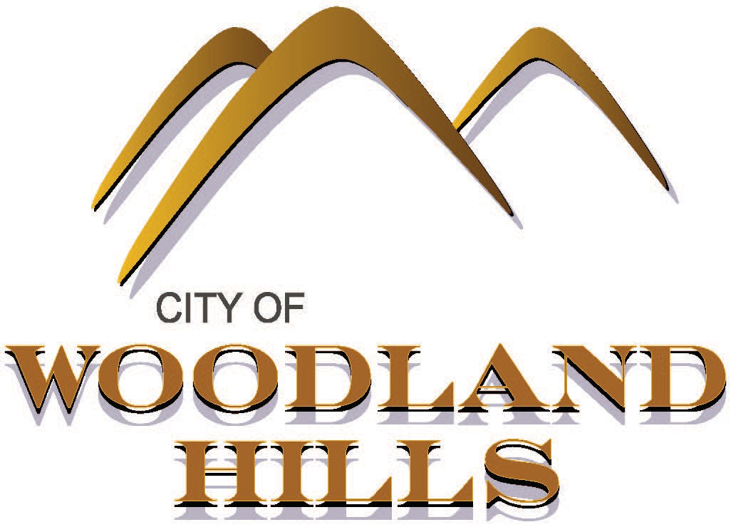
City of Woodland Hills
690 S. Woodland Hills Drive Woodland Hills, UT 84653
801-423-3900
www.woodlandhills-ut.gov

Election Results:
Results will also be posted on the Utah County Election Web Page
As of 11/12/2021 (NOT FINAL)

Mayor
Round One: Round Two:
Brent Winder- 269 (41.1%) Brent Winder- 331 (55.4%)
Benjamin J Hillyard- 196 (29.9%) Benjamin J Hillyard- 267 (44.6%)
Mike Lauritzen- 190 (29%) Mike Lauritzen- eliminated

City Council 1st Seat
After Three Rounds:
Janet Lunt- 415 (65.7%)
Toby M. Harding 217 (34.3%)
Dorel B. Kynaston- eliminated
Cody Chamberlain- eliminated

City Council 2nd Seat
After Two Rounds:
Dorel B. Kynaston- 357 (58.8%)
Toby M. Harding- 250 (41.2%)
Cody Chamberlain- eliminated

Results will be finalized November 16th, 2021.

