**WOODLAND HILLS CITY COUNCIL**

**Public Hearing**

**Woodland Hills City Center, 690 South Woodland Hills Dr.**

**Tuesday, May 27, 2025**

CONDUCTING Mayor Pro-Tempore/Council Member Ben Hillyard

ELECTED OFFICIALS Council Member Brian Hutchings

Council Member Janet Lunt

Council Member Kari Malkovich

Council Member Dorel Kynaston

ELECTRONICALLY Mayor Brent Winder

STAFF PRESENT Ted Mickelsen, Public Works Dir./Fire Chief

Chris Helvey, Finance Director- Electronically

Jody Stones, City Recorder

Wayne Frandsen, Code Enforcement and Planning Commission

**Public Hearing**

Resident Sherry Burger informed the council the Utah Outdoor Recreation Grant had not been approved. She inquired whether the $26,000 in the 2026 budget could automatically roll over to the next year, or if reapplication in March 2026 would require City Council approval and restarting the process.

Chris Helvey confirmed that the Council could reauthorize the funding at that time.

Hearing no further comments, the public hearing was closed, and the Council moved on to the Work Session. Close the public hearing at 6:05 p.m.

**WOODLAND HILLS CITY COUNCIL**

**Work Session**

**Woodland Hills City Center, 690 South Woodland Hills Dr.**

**Tuesday, May 27, 2025**

CONDUCTING Mayor Pro-Tempore/Council Member Ben Hillyard

ELECTED OFFICIALS Council Member Brian Hutchings

Council Member Janet Lunt

Council Member Kari Malkovich

Council Member Dorel Kynaston

ELECTRONICALLY Mayor Brent Winder

STAFF PRESENT Ted Mickelsen, Public Works Dir./Fire Chief

Chris Helvey, Finance Director- Electronically

Jody Stones, City Recorder

Wayne Frandsen, Code Enforcement and Planning Commission

**Work Session**

**2. Proposed Ordinance 2025-22 Amending Portion of the City Code 10.18.1: Accessory Dwelling Units**.

Wayne Frandsen mentioned he planning commission held a public hearing, and no public input was received. Ordinance 2025-22 would amend parts of City Code 10.18.1 concerning accessory dwelling units. Changes in state law that allowed for external accessory dwellings led to an update in the ordinance. Now, regardless of whether they are internal or external, these structures can be classified as accessory buildings.

**3. Proposed Ordinance 2025-23 Adopting Gates to City Code 10.16.9**

Wayne Frandsen noted the proposed change to City Code 10.16.9 related to driveway gates. A few residents had expressed interest in installing gates, but there was no existing ordinance directly addressing this issue. The closest existing regulation was part of the Wildland Fire Ordinance, which required driveways to be unobstructed, with a minimum width of 12 feet and a minimum height of 13.5 feet.

Unobstructed could be interpreted in various ways, whether a gate was present or not. The planning commission had put together a set of standards for gates, which were included in the packet. Although these standards were extensive, each had a purpose.

After some discussion, the planning commission decided to add to the standards that the city could test the gate after it was repaired to ensure it functioned properly and opened with a yelp siren at least once a year.

Mr. Frandsen stated that the gate could not be taller than the maximum fence height of 6 feet. There was a section indicating that a non-functioning gate could lead to a $500 fine. Additionally, if someone chained the gate closed so it could not be opened, they could be fined because it had to remain operable.

Concerns had been raised about snow possibly being packed in front of the gate. This posed not only a fire hazard to the resident near the gate but also to neighboring residents. All these factors needed to be taken into consideration.

Council Member/Mayor Pro-Tempore Ben Hillyard appreciated the safety measures incorporated into that ordinance and inquired if there was a regulation requiring a permit for installing a gate.

Mr. Frandsen indicated a permit would be required.

**4. Update on Employee Health Insurance**

Chris Helvey mentioned that he had sent a message earlier regarding his personal challenges with health insurance due to his current living situation. He requested that the Council and mayor consider reimbursing him for the portion the city currently pays so he could obtain his own health insurance.

Mayor Brent Winder added that Chris had spoken to him about the matter. He believed that it didn't require specific council approval but wanted to include it on the agenda for full transparency. Winder agreed with Chris's recommendation to provide proof of purchase and thought it was a good approach, emphasizing the importance of not just handing out checks. He mentioned that if the insurance was not functioning properly, they should make any possible accommodations. Since there was no additional expense, Winder viewed it as an administrative decision but still wanted the Council to be informed for clarity.

Council Member and Mayor Pro-Tempore Ben Hillyard confirmed that there were no additional expenses beyond what the Council had previously approved.

Chris Helvey mentioned that personally, he would incur slightly higher out-of-pocket costs in the past. However, he clarified that there was no additional expense to the city at that time. He noted that the city paid $1,872.44 per employee per month who is enrolled on the plan, and he only requested that amount. He also indicated that the rate for the plan he would be moving to would be $1,965 per month.

Council Member Hutchings asked if any amendments needed to be made to allow for it.

Wayne Frandsen inquired whether all employees qualify for the same exception as Mr. Helvey.

Council Member Lunt asked if this set a precedent that others could also request funds and seek their own insurance.

Mayor Brent Winder emphasized that while there might have been certain considerations, Mr. Helvey’s situation was somewhat unique because of working remotely and no longer living in Utah. He acknowledged that even if it set a precedent, he didn’t see why it would be problematic, especially if the city approved a certain amount and it remained a workable solution.

Council Member Hutchings expressed that he did not see a problem with the situation, especially if receipts were submitted showing payment and reimbursement was sought. Council Member and Mayor Pro-Tempore Ben Hillyard stated that if it did not affect taxpayers differently, he had no issue with it. Mayor Brent Winder added that his bigger concern was ensuring the city was not subject to contractual damages under the current plan, now that they were outside of open enrollment, and suggested that Mr. Helvey address this. Mr Helvey agreed and said he would double-check with PEHP..

Council Member Lunt mentioned that Mr. Helvey was already aware of her concerns. She emphasized that she did not want it to increase costs for taxpayers, especially now that Mr. Helvey had relocated to Hawaii, noting that her primary focus was ensuring consistency in the application of policies across all employees.

City Recorder Jody Stones inquired whether other employees on the plan have the same option as Mr. Helvey, who was being offered a choice if they were dissatisfied with PEHP. She also noted that the City had pre-funded $3,000 into an HSA and inquired about the situation if the new plan did not include an HSA.

Council Member and Mayor Pro-Tempore Ben Hillyard would like to confirm that there is no penalty for a withdrawal. If a withdrawal penalty was in place, he assumed Mr. Helvey would speak with the Mayor before moving forward.

**5. Department Updates**

**Public Works**- Ted Mickelsen: discussed the Maple Canyon project, noting that it had been completed and was now undergoing testing, including pump and water quality testing. He expressed hope that within the next few days, the well would be operational again, allowing the city to move forward with finishing the Broadhollow Well. He mentioned that some valves had been delayed but were expected to arrive by June 7th, and he hoped that this would enable the project to resume. He also reported that the pavement preservation project scheduled for summer had been postponed to August due to scheduling conflicts, with work now planned toward the end of August. He explained that the delay was due to conflicts with Comcast working on the streets and that they preferred not to perform micro seal work while Comcast was active. He estimated at least a month's delay but was optimistic that the timing would still work out.

In previous council updates, Mr. Mickelsen mentioned raising the possibility of flood mitigation efforts in Summit Creek. Engineers were assigned to create a scope and estimate for these efforts. It was also noted that a FEMA-funded flood study had been completed, although the program has now ended. This study was finished just in time and included several recommendations, such as measures to reduce flooding in Elk Ridge caused by runoff from the city. Some suggested improvements are simple and could greatly benefit Elk Ridge. Engineers have been preparing a scope and fee proposal, which will be reviewed with the mayor, to implement these measures in the Summit Creek basin. While many projects are planned, the initial focus is on these easy-to-start initiatives, seen as the 'low-hanging fruit" that can be addressed promptly.

**Fire:** Chief Mickelsen reported the wildland fire crew started full-time last week and expects to be available in two weeks. They include two full-time members in addition to the engine boss, with an additional backup who is full-time for training and part-time when in the city. The state has confirmed that four personnel can be dispatched to a fire. The chipper crew is progressing quickly and aims to finish by the end of the week. The Relief Mine obtained a burn permit from Utah County, with all surrounding agencies notified, and strict conditions were applied to the permit.

**Code and Zoning Enforcement**: Wayne Frandsen noted there have been no code complaints in the last few weeks.

Sherry Burger asked what was being done about the helicopter flying over the city, as it flew again.

Wayne Frandsen responded that a city resident apparently owns a helicopter, but currently, there were only restrictions by the FAA regarding flight plans. The city had no authority to regulate that, and he mentioned he hadn't looked into it further. He noted it was questionable whether any limitations could be imposed, but no steps had been taken to pursue such limitations.

6. **Mayor and City Council Reports:**

**Personnel:** Mayor Winder had nothing to report, except for the insurance request that was previously discussed in the meeting.

**Emergency Management:** Council Member Hillyard mentioned he couldn't attend the County Emergency Management meeting but noted that Council Member Malkovich was present. Council Member Malkovich reported that the meeting was productive, with a focus on Utah's response to hurricane victims of the most recent hurricanes in the south.

**Public Works Committee/PTR/Planning Commission:** Council Member Hutchings noted that a Public Works Committee meeting had not been held. He appreciated the council appreciated listening to the Dark Skies Presentation. He was able to have a brief discussion with the state ombudsman regarding dark skies and the related requirements, but there is still some work to be done.

**Public Safety**: Council Member Kynaston attended a recognition dinner held by Mountain View Hospital. Resident Alan Wakefield was recognized for his 48 years of service and Ted Mickelsen received the EMT of the year award.

**Finance/Communication/Events:** Council Member Lunt mentioned that the finance committee has not convened since her previous report. The newsletter is expected to be ready for release in the coming days, and progress is being made on the Woodland Hills Day history project. She is also seeking early city logos for this year's Woodland Hills Days t-shirts.

**Public Works/Community Development:** Council Member Malkovich reported that the Community Development Committee met on May 12th. They discussed and reviewed the goals and objectives, and will begin work on the General Plan.

Wayne Frandsen asked for reassurance that funding will be available for the planning commission to return to Sunrise with updates to the General Plan.

**7. Budget Retreat**

Chris Helvey addressed some issues in the budget, emphasizing the importance of discussing the beginning balances. He noted that this is particularly relevant when deciding whether to hold a truth and taxation hearing. He also highlighted that, unlike in the past, a vote on a tentative budget is required tonight. The budget presented a few weeks ago was detailed, but recent discussions have brought the beginning balances into focus.

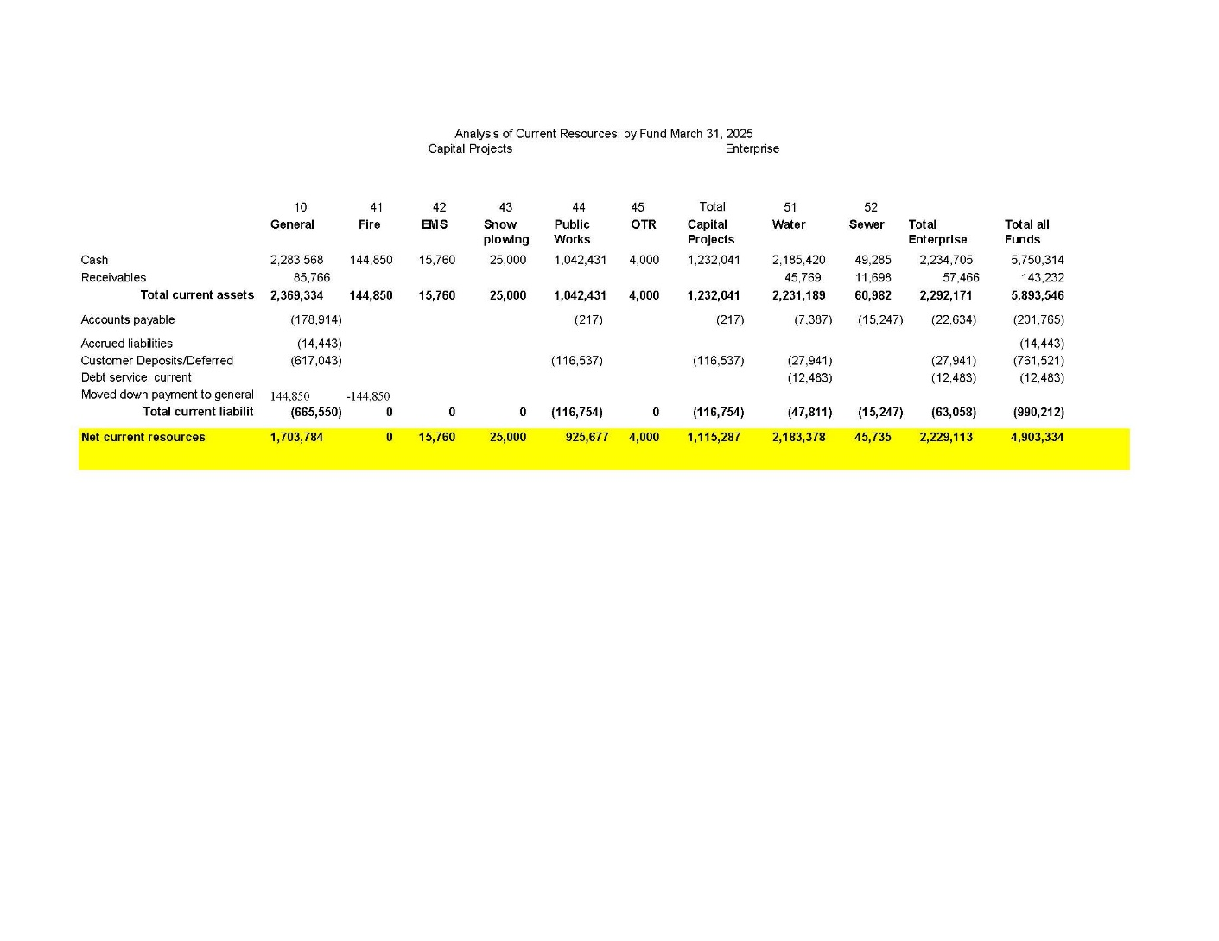

Mr. Helvey walked the council through what the columns represented. He explained that the left-hand side consisted of some of the accounts on the balance sheet, such as cash, receivables, and accounts payable. Each of the columns corresponded to different funds, like Fund 41 for the fire truck savings, Fund 42 for ambulance savings, and Fund 43 for additional purposes. These aligned with the city’s financials.

He pointed out that having some fund balances was a blessing, as it meant there were savings for potential future needs and asked Ted Mickelsen to comment on the road projects that may need to be done within the next one to two years.

Ted Mickelsen confirmed $500,000 in road projects were already under contract, with another $500,000 planned for FY2026. He stated that $2.8 million in additional road projects beyond 2027 could be partially offset by water infrastructure projects.

Mr. Helvey noted that the tentative FY2026 budget proposed would require the city council to use reserves to balance the budget and recommended that the council vote to keep the current property tax rate to generate additional revenue, noting that a truth in taxation hearing would need to be held to maintain the current tax rate.

Council Member Lunt favored a smaller increase now over a larger hike later. Mayor Winder supported holding the rate steady, which would yield more revenue without altering the rate itself. Council Member Malkovich emphasized the importance of sustainable funding and preserving the rainy day fund. She questioned whether holding the rate flat would be sufficient to meet the city's needs.

Council Member Kynaston opposed building up too much savings, arguing it unfairly leveraged contributions from past residents. Sherry Burger pointed out that residents already faced substantial costs from utilities and other fees.

Mr. Helvey explained that maintaining the current rate might look like a tax increase because of rising home values. He expects to receive the final tax rate data from the state within three weeks.

Council Member and Mayor Pro Tempore Hillyard would like to examine multiple revenue scenarios before making decisions.

Ted Mickelsen spoke to the benefits of debt financing as a means to fund infrastructure while preserving savings for emergencies, especially water-related issues. He noted emergency reserves could also serve as leverage for grants or matching funds.

The Council agreed to revisit the issue when certified rate data became available, preferably at the June 24th meeting, and supported involving the Finance Committee again.

Council Member Malkovich suggested scheduling the truth in taxation hearing for August 26th.

Council Member and Mayor Pro Tempore Hillyard mentioned that showing residents some clear numbers might help them decide: they can either keep the current rate or go for a small increase.

Mr. Helvey closed by emphasizing the need to set a tentative rate soon, recommending that a slightly higher rate than expected be chosen, as it could be lowered later but not raised once noticed.

The work session was adjourned at 7:33 p.m.

**WOODLAND HILLS CITY COUNCIL**

**City Council Meeting**

**Woodland Hills City Center, 690 South Woodland Hills Dr.**

**Tuesday, May 27, 2025**

CONDUCTING Mayor Pro-Tempore/Council Member Ben Hillyard

ELECTED OFFICIALS Council Member Brian Hutchings

Council Member Janet Lunt

Council Member Kari Malkovich

Council Member Dorel Kynaston

ELECTRONICALLY Mayor Brent Winder

STAFF PRESENT Ted Mickelsen, Public Works Dir./Fire Chief

Chris Helvey, Finance Director- Electronically

Jody Stones, City Recorder

Wayne Frandsen, Code Enforcement and Planning Commission

**Call to Order**: Council Member and Mayor Pro Tempore Ben Hillyard called the meeting to order at 7:42 p.m.

**Invocation:** Council Member Hillyard offered the invocation.

**Pledge of Allegiance**: Council Member Hutchings invited those in attendance to join him in reciting the Pledge of Allegiance.

**Public Comment:** No public comment was heard.

**Consent Agenda:**

**Motion:** Council Member Malkovich moved to approve the April 22, 2025, City Council Meeting Minutes.

**Second:** Council Member Hutchings seconded the motion.

**Vote:** Motion passed unanimously**.**

**Business and Discussion**

**13. Ordinance 2025-22 Smending portion of City Code 10.18.1- Accessory Dwelling Units.**

**Motion:** Council Member Malkovich moved to adopt Ordinance 2025-22.

**Second:** Council Member Lunt seconded the motion.

**Vote:** Motion passed unanimously **with a roll call vote.**

**14. Ordinance 2025-23 Amending City Code 10.16.9 Driveway to Parking Areas to Allow for Gates.**

**Motion:** Council Member Kynaston moved to adopt Ordinance 2025-23.

**Second:** Council Member Hutchings seconded the motion.

**Vote:** Motion passed unanimously **with a roll call vote.**

**15. Resolution 2025-13 Adopting the Tentative 2026 Fiscal Year Budget**

**Motion:** Council Member Hutchings moved to adopt Resolution 2025-13

**Second:** Council Member Malkovich seconded the motion.

**Vote:** Motion passed unanimously**.**

**Closed Session:**

**Motion:** Council Member Hutchings moved for the council to enter into a Closed Session to discuss pending litigation.

**Second:** Council Member Malkovich seconded the motion.

**Vote:** Motion passed unanimously **with a roll call vote.**

**Council entered into a closed session at 7:51 p.m**. The purpose of the closed session was to discuss pending litigation. In attendance in the closed session were: Mayor Winder(electronically), Council Members Hillyard, Hutchings, Kynaston, Lunt, and Malkovich; Staff: Ted Mickelsen, Wayne Frandsen, Jody Stones, and Chris Helvey (electronically).

**Motion:** Council Member Malkovich moved to adjourn the Closed Session and reconvene the open city council meeting at 8:09 p.m.

**Second:** Council Member Hutchings seconded the motion.

**Vote:** The motion was approved unanimously via roll call vote.

**Business and Discussion**

**Motion:** Council Member Malkovich moved to adjourn at 8:09 p.m.

**Second:** Council Member Hutchings seconded the motion.

**Meeting Adjourned.**

**_________________________**

**Jody Stones, City Recorder**